EXPT: 1 DATE:

PROGRAM USING CLASSES & OBJECTS

AIM:
To develop a java application to generate the electricity bill.

ALGORITHM:

Step 1: Start the netbeansIDE8.2
Step 2: Goto FILE-> new project->java->java application->click next
Step 3: Give the name for the application->Click Finish.
Step 4: Create a class names EBbillCalculation with the necessary variables.
Step 5: Create getdetails() which gets the basic information form the user
Step 6: Create two more method Domestic_Calculation & Commerical_Calculation to calculate the bill and print it.
Step 7: Stop the program.

PROGRAM:

import java.io.*;
import java.util.*;
class EBbillCalculation
{
int cno;
String cname;
int pm_reading,cm_reading,units; double billpay;
void getdetails()
{
Scanner in = new Scanner(System.in);
System.out.println("Enter the Consumer No:");
cno=in.nextInt();
System.out.println("Enter the Consumer Name:");
cname=in.next();
System.out.println("Enter the Previous Month Reading:");
pm_reading=in.nextInt();
System.out.println("Enter the Current Month Reading:");
cm_reading=in.nextInt();
units= cm_reading-pm_reading;
System.out.println("Choose the type of EB Connection 1.Domestic connection 2. Commercial connection");
int ch=in.nextInt();
switch(ch)
{
case 1:
Domestic_Calculation(units);
break;
case 2:
Commercial_Calculation(units);
break;
}
}
void Domestic_Calculation(int units)
{
billpay = 0; if(units<=100)
{
billpay=units*1.00;
}
else if(units>100 && units<=200)
{
billpay=100*1.00+(units-100)*2.50;
}
else if(units>200 && units<=500)
{
billpay=100*1.00+200*2.50+(units-200)*4.00;
}
else if(units>500)
{
billpay =100*1.00+200*2.50+500*4.00+(units-500)*6.00;
}
show();
System.out.println("Amount to be Paid : " + billpay);
}
void Commercial_Calculation(int units)
{
billpay = 0; if(units<=100)
{
billpay=units*2.00;
}
else if(units>100 && units<=200)
{
billpay=100*2.00+(units-100)*4.50;
}
else if(units>200 && units<=500)
{
billpay=100*2.00+200*4.50+(units-200)*6.00;
}
else if(units>500)
{
billpay =100*2.00+200*4.50+500*6.00+(units-500)*7.00;
}
show();
System.out.println("Amount to be Paid : " + billpay);
}
public void show()
{
System.out.println("Customer Number : " + cno);
System.out.println("Customer Name : " + cname);
System.out.println("Units Consumed : " + units);
}
}
class Main
{
public static void main(String[] args)
{
EBbillCalculation eb=new EBbillCalculation();
eb.getdetails();
}
}

OUTPUT:
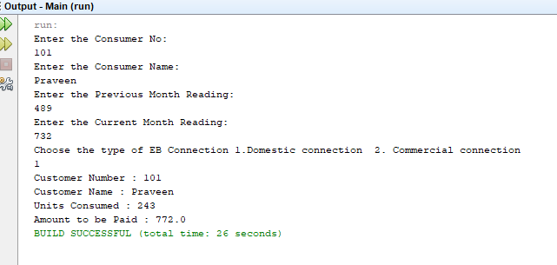

RESULT:

Thus the java application for generating the electricity bill is created and executed successfully.

EXPT:2DATE:

PROGRAM USING PACKAGES
AIM:
To develop a java application to implement currency converter, distance converter and time converter using the concept of packages.

ALGORITHM:
- Create a Package currencyconversion and place the class currency under the package
- Create the methods to perform currency conversion from dollar to rupee ,rupee to dollar,euro to rupee , rupee to euro , yen to rupee and rupee to yen.
- Create the package distanceconverion and create the class distance within the package
- Create the methods to convert from meter to km, km to meter, miles to km,km to miles
- Create the package timeconversion and create the class timer .Create the methods to convert from hours to minutes ,hours to seconds , minutes to hours and seconds to hours
- Create a class and import the packages currencyconversion,distanceconversion and time conversion.Create the objects for the class currency,distance and timer.
- Get the choice from the user and invoke the methods to perform the corresponding conversion and display the value.

PROGRAM:
currency.java
package currencyconversion;
import java.util.*;
public class currency
{
int inr,usd;
int euro,yen;
Scanner in=new Scanner(System.in);
public void dollartorupee()
{
System.out.println("Enter dollars to convert into Rupees:");
usd=in.nextInt();
inr=usd*67;
System.out.println("Dollar ="+usd+"equal to INR="+inr);
}
public void rupeetodollar()
{
System.out.println("Enter Rupee to convert into Dollars:");
inr=in.nextInt();
usd=inr/67;
System.out.println("Rupee ="+inr+"equal to Dollars="+usd);
}
public void eurotorupee()
{
System.out.println("Enter euro to convert into Rupees:");
euro=in.nextInt();
inr=euro*79.50;
System.out.println("Euro ="+euro +"equal to INR="+inr);
}
public void rupeetoeuro()
{
System.out.println("Enter Rupees to convert into Euro:");
inr=in.nextInt();
euro=(inr/79.50);
System.out.println("Rupee ="+inr +"equal to Euro="+euro);
}
public void yentorupee()
{
System.out.println("Enter yen to convert into Rupees:");
yen=in.nextInt();
inr=yen*0.61;
System.out.println("YEN="+yen +"equal to INR="+inr);
}
public void rupeetoyen()
{
System.out.println("Enter Rupees to convert into Yen:");
inr=in.nextInt();
yen=(inr/0.61);
System.out.println("INR="+inr +"equal to YEN"+yen);
}
}
distance.java
package distanceconversion;
import java.util.*;
public class distance
{
double km,m,miles;
Scanner sc = new Scanner(System.in);
public void kmtom()
{
System.out.print("Enter in km ");
km=sc.nextDouble();
m=(km*1000);
System.out.println(km+"km" +"equal to"+m+"metres");
}
public void mtokm()
{
System.out.print("Enter in meter ");
m=sc.nextDouble();
km=(m/1000);
System.out.println(m+"m" +"equal to"+km+"kilometres");
}
public void milestokm()
{
System.out.print("Enter in miles");
miles=sc.nextDouble();
km=(miles*1.60934);
System.out.println(miles+"miles" +"equal to"+km+"kilometres");
}
public void kmtomiles()
{
System.out.print("Enter in km");
km=sc.nextDouble();
miles=(km*0.621371);
System.out.println(km+"km" +"equal to"+miles+"miles");
}
}
timer.java
package timeconversion;
import java.util.*;
public class timer
{
int hours,seconds,minutes;
int input;
Scanner sc = new Scanner(System.in);
public void secondstohours()
{
System.out.print("Enter the number of seconds: ");
input = sc.nextInt();
hours = input / 3600;
minutes = (input % 3600) / 60;
seconds = (input % 3600) % 60;
System.out.println("Hours: " + hours);
System.out.println("Minutes: " + minutes);
System.out.println("Seconds: " + seconds);
}
public void minutestohours()
{
System.out.print("Enter the number of minutes: ");
minutes=sc.nextInt();
hours=minutes/60;
minutes=minutes%60;
System.out.println("Hours: " + hours);
System.out.println("Minutes: " + minutes);
}
public void hourstominutes()
{
System.out.println("enter the no of hours");
hours=sc.nextInt();
minutes=(hours*60);
System.out.println("Minutes: " + minutes);
}
public void hourstoseconds()
{
System.out.println("enter the no of hours");
hours=sc.nextInt();
seconds=(hours*3600);
System.out.println("Minutes: " + seconds);
}
}
converter.java
import java.util.*;
import java.io.*;
import currencyconversion.*;
import distanceconversion.*;
import timeconversion.*;
class converter
{
public static void main(String args[])
{
Scanner s=new Scanner(System.in);
int choice,ch;
currency c=new currency();
distance d=new distance();
timer t=new timer();
do
{
System.out.println("1.dollar to rupee ");
System.out.println("2.rupee to dollar ");
System.out.println("3.Euro to rupee ");
System.out.println("4..rupee to Euro ");
System.out.println("5.Yen to rupee ");
System.out.println("6.Rupee to Yen ");
System.out.println("7.Meter to kilometer ");
System.out.println("8.kilometer to meter ");
System.out.println("9.Miles to kilometer ");
System.out.println("10.kilometer to miles");
System.out.println("11.Hours to Minutes");
System.out.println("12.Hours to Seconds");
System.out.println("13.Seconds to Hours");
System.out.println("14.Minutes to Hours");
System.out.println("Enter ur choice");
choice=s.nextInt();
switch(choice)
{
case 1:
{
c.dollartorupee();
break;
}
case 2:
{
c.rupeetodollar();
break;
}
case 3:
{
c.eurotorupee();
break;
}
case 4:
{
c.rupeetoeuro();
break;
}
case 5:
{c.yentorupee();
break;}
case 6 :
{
c.rupeetoyen();
break;
}
case 7 :
{
d.mtokm();
break;
}
case 8 :
{
d.kmtom();
break;
}
case 9 :
{
d.milestokm();
break;
}
case 10 :
{
d.kmtomiles();
break;
}
case 11 :
{
t.hourstominutes();
break;
}
case 12 :
{
t.hourstoseconds();
break;
}
case 13 :
{
t.secondstohours();
break;
}
case 14 :
{
t.minutestohours();
break;
}}
System.out.println("Enter 0 to quit and 1 to continue ");
ch=s.nextInt();
}while(ch==1);
}
}

OUTPUT:
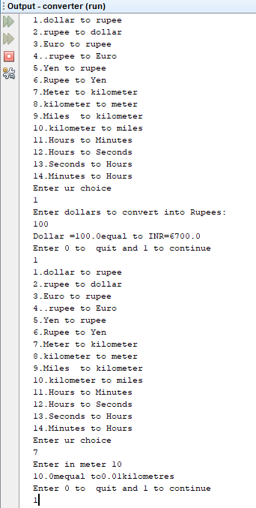

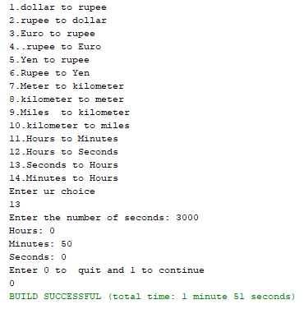

RESULT:
Thus the java application to implement currency converter, distance converter and time converter was implemented and executed successfully.

EXPT:3DATE:

PROGRAM USING INHERITANCE

AIM:
To develop a java application to generate pay slip for different category of employees using the concept of inheritance.

ALGORITHM:
- Create the class employee with name, Empid, address, mailid, mobileno as members.
- Inherit the classes programmer, asstprofessor, associateprofessor and professor from employee class.
- Add Basic Pay (BP) as the member of all the inherited classes.
- Calculate DA as 97% of BP, HRA as 10% of BP, PF as 12% of BP, Staff club fund as 0.1% of BP.
- Calculate gross salary and net salary.
- Generate pay slip for all categories of employees.
- Create the objects for the inherited classes and invoke the necessary methods to display the Pay slip.

PROGRAM:
import java.util.*;
import java.io.*;
class employee
{
int empid;
long mobile;
String name, address, mailid;
Scanner get = new Scanner(System.in);
void getdata()
{
System.out.println("Enter Name of the Employee");
name = get.nextLine();
System.out.println("Enter Mail id");
mailid = get.nextLine();
System.out.println("Enter Address of the Employee:");
address = get.nextLine();
System.out.println("Enter employee id ");
empid = get.nextInt();
System.out.println("Enter Mobile Number");
mobile = get.nextLong();
}
void display()
{
System.out.println("Employee Name: "+name);
System.out.println("Employee id : "+empid);
System.out.println("Mail id : "+mailid);
System.out.println("Address: "+address);
System.out.println("Mobile Number: "+mobile);
}
}
class programmer extends employee
{
double salary,bp,da,hra,pf,club,net,gross;
void calculateprog()
{
System.out.println("Enter basic pay");
bp = get.nextDouble();
da=(0.97*bp);
hra=(0.10*bp);
pf=(0.12*bp);
club=(0.1*bp);
gross=(bp+da+hra);
net=(gross-pf-club);
System.out.println("************************************************");
System.out.println("PAY SLIP FOR PROGRAMMER");
System.out.println("************************************************");
System.out.println("Basic Pay:Rs"+bp);
System.out.println("DA:Rs"+da);
System.out.println("PF:Rs"+pf);
System.out.println("HRA:Rs"+hra);
System.out.println("CLUB:Rs"+club);
System.out.println("GROSS PAY:Rs"+gross);
System.out.println("NET PAY:Rs"+net);
}
}
class asstprofessor extends employee
{
double salary,bp,da,hra,pf,club,net,gross;
void calculateasst()
{
System.out.println("Enter basic pay");
bp = get.nextDouble();
da=(0.97*bp);
hra=(0.10*bp);
pf=(0.12*bp);
club=(0.1*bp);
gross=(bp+da+hra);
net=(gross-pf-club);
System.out.println("************************************************");
System.out.println("PAY SLIP FOR ASSISTANT PROFESSOR");
System.out.println("************************************************");
System.out.println("Basic Pay:Rs"+bp);
System.out.println("DA:Rs"+da);
System.out.println("HRA:Rs"+hra);
System.out.println("PF:Rs"+pf);
System.out.println("CLUB:Rs"+club);
System.out.println("GROSS PAY:Rs"+gross);
System.out.println("NET PAY:Rs"+net);
}
}
class associateprofessor extends employee
{
double salary,bp,da,hra,pf,club,net,gross;
void calculateassociate()
{
System.out.println("Enter basic pay");
bp = get.nextDouble();
da=(0.97*bp);
hra=(0.10*bp);
pf=(0.12*bp);
club=(0.1*bp);
gross=(bp+da+hra);
net=(gross-pf-club);
System.out.println("************************************************");
System.out.println("PAY SLIP FOR ASSOCIATE PROFESSOR");
System.out.println("************************************************");
System.out.println("Basic Pay:Rs"+bp);
System.out.println("DA:Rs"+da);
System.out.println("HRA:Rs"+hra);
System.out.println("PF:Rs"+pf);
System.out.println("CLUB:Rs"+club);
System.out.println("GROSS PAY:Rs"+gross);
System.out.println("NET PAY:Rs"+net);
}
}
class professor extends employee
{
double salary,bp,da,hra,pf,club,net,gross;
void calculateprofessor()
{
System.out.println("Enter basic pay");
bp = get.nextDouble();
da=(0.97*bp);
hra=(0.10*bp);
pf=(0.12*bp);
club=(0.1*bp);
gross=(bp+da+hra);
net=(gross-pf-club);
System.out.println("************************************************");
System.out.println("PAY SLIP FOR PROFESSOR");
System.out.println("************************************************");
System.out.println("Basic Pay:Rs"+bp);
System.out.println("DA:Rs"+da);
System.out.println("HRA:Rs"+hra);
System.out.println("PF:Rs"+pf);
System.out.println("CLUB:Rs"+club);
System.out.println("GROSS PAY:Rs"+gross);
System.out.println("NET PAY:Rs"+net);
}
}
class Main
{
public static void main(String args[])
{
int choice,cont;
do
{
System.out.println("PAYROLL");
System.out.println(" 1.PROGRAMMER \t 2.ASSISTANT PROFESSOR \t 3.ASSOCIATE PROFESSOR \t 4.PROFESSOR ");
Scanner c = new Scanner(System.in);
choice=c.nextInt();
switch(choice)
{
case 1:
{
programmer p=new programmer();
p.getdata();
p.display();
p.calculateprog();
break;
}
case 2:
{
asstprofessor asst=new asstprofessor();
asst.getdata();
asst.display();
asst.calculateasst();
break;
}
case 3:
{
associateprofessor asso=new associateprofessor();
asso.getdata();
asso.display();
asso.calculateassociate();
break;
}
case 4:
{
professor prof=new professor();
prof.getdata();
prof.display();
prof.calculateprofessor();
break;
}
}
System.out.println("Do u want to continue 0 to quit and 1 to continue ");
cont=c.nextInt();
}while(cont==1);
}
}

OUTPUT:
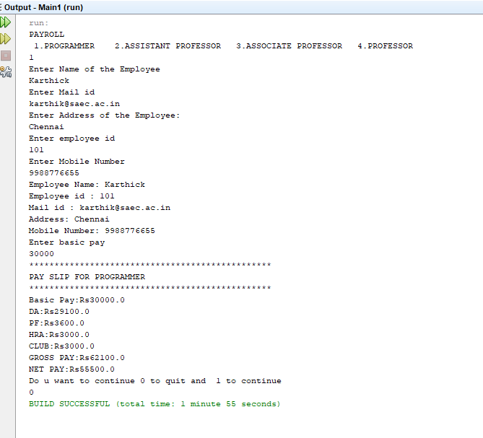

RESULT:
Thus the java application to generate pay slips for different categories of employees was implemented using inheritance and the program was executed successfully.

EXPT: 4 DATE:

IMPLEMENTATION OF STACK ADT USING INTERFACE

AIM:
To develop a program using Java interface for ADT Stack

ALGORITHM:

Step 1: Start the netbeansIDE8.2
Step 2: Goto FILE-> new project->java->java application->click next
Step 3: Give the name for the application->Click Finish.
Step 4: Create an interface Mystack with methods push,pop,display.
Step 5: Create a class stack_array which implements the interface Mystack
Step 6: Create the main class with switch case which gets the input from the user to Push / Pop / Display

PROGRAM:
import java.io.*;
import java.util.*;
interface Mystack
{
public void pop();
public void push();
public void display();
}
class Stack_array implements Mystack
{
final static int n=5;
int stack[]=new int[n];
int top=-1;
public void push()
{
Scanner br=new Scanner(System.in);
if(top==(n-1))
{
System.out.println(" Stack Overflow");
return;
}
else
{
System.out.println("Enter the element");
int ele=br.nextInt();
stack[++top]=ele;
}
}
public void pop()
{
if(top<0)
{
System.out.println("Stack underflow");
}
else
{
int popper=stack[top]; top--;
System.out.println("Popped element:" +popper);
}
}
public void display()
{
if(top<0)
{
System.out.println("Stack is empty");
}
else
{
String str=" ";
for(int i=0; i<=top; i++)
str=str+" "+stack[i]+" <--";
System.out.println("Elements are:"+str);
}
}
}
class Stackadt
{
public static void main(String arg[])throws IOException
{
Scanner br=new Scanner(System.in);
System.out.println("Implementation of Stack using Array");
Stack_array stk=new Stack_array();
int ch=0; do
{
System.out.println("1.Push 2.Pop 3.Display 4.Exit");
System.out.println("Enter your choice:");
ch=br.nextInt();
switch(ch)
{
case 1:
stk.push();
break;
case 2:
stk.pop();
break;
case 3:
stk.display();
break;
case 4:
System.exit(0);
}
}
while(ch<5);
}
}

OUTPUT:
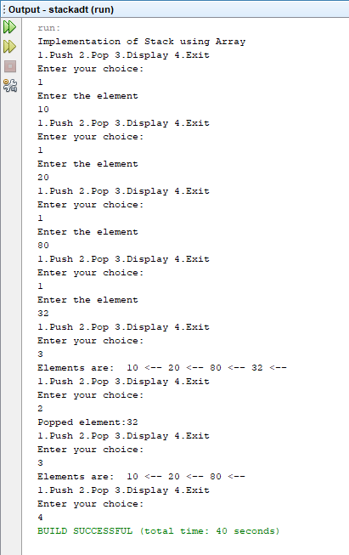

RESULT:
Thus the program for using Java interface for ADT Stack has been written and executed successfully.

EXPT: 5 DATE:

IMPLEMENTATION OF STACK ADT USING INTERFACE

AIM:

To write a java program to perform string operations using Array List.

ALGORITHM:

Step 1: Start the netbeansIDE8.2
Step 2: Goto FILE-> new project->java->java application->click next
Step 3: Give the name for the application->Click Finish.
Step 4: Create an Array list named a, a2 and add the strings using add()method.
Step 5: Append the a2 to the end of a Using addAll() method .
Step 6: Search the string in Arraylist by using contain() method. if the string is found , print search is successful otherwise try again.
Step 7: Print all string starts with given letter by using matches() method.
Step 8: Stop the program.

PROGRAM:

import java.util.*;

public class Demo

{

public static void main(String args[])

{

ArrayList<String> a = new ArrayList<>();

a.add("book");

a.add("cook");

a.add("HTML");

System.out.println("Printing list1:");

System.out.println(a);

a.add(1,"PHP");

System.out.println("(After Insertion)Printing list1:");

System.out.println(a);

ArrayList<String> a2 = new ArrayList<>();

a2.add("cat");

a2.add("bat");

a2.add("hat");

a2.add("Jump");

System.out.println("Printing list2:");

System.out.println(a2);

a.addAll(a2);

System.out.println("( After Appended)Printing all the elements");

System.out.println(a);

System.out.println("SEARCH STRING IN ARRAY LIST");

System.out.println("###########################");

Scanner in = new Scanner(System.in);

System.out.println("ENTER THE STRING TO BE SEARCH:");

String searchString=in.next();

boolean Found = a.contains(searchString);

if(Found)

System.out.println("SUCCESS!!! String is available in the Arraylist");

else

System.out.println("Failure!!! Try Again");

System.out.println("Enter the starting letter for the word to be searched");

String c=in.next();

for(int i=0;i<a.size();i++)

{

if(a.get(i).startsWith(c))

{

System.out.println(a.get(i));

}

}

System.out.println(a);

}

}

OUTPUT:

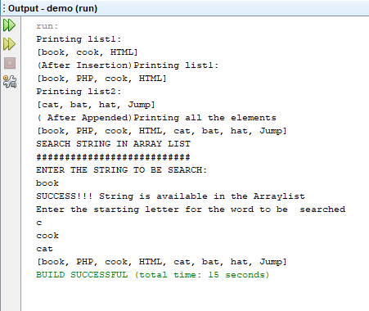

RESULT:
Thus the program to implement array list is has written and implemented successfully.

EXPT: 6 DATE:

PROGRAM USING ABSTRACT CLASS AND POLYMORPHISM

AIM:

To write a java program to create an abstract class named Shape .

ALGORITHM:

Step 1: Start the netbeansIDE8.2
Step 2: Goto FILE-> new project->java->java application->click next Step 3: Give the name for the application->Click Finish.
Step 4: Create an abstract class named Shape that contains two integers and an empty method named print Area()
Step 5: Create three classes named Rectangle, Triangle and Circle which extends Shape
Step 6: Print the area of the given shapes. Step 7: Stop the program.

PROGRAM:

abstract class Shape
{
double a=3,b=4;
abstract void Area();
}
class Rectangle extends Shape
{
double rectarea;
void Area()
{
rectarea=a*b;
System.out.println("Area of rectangle is: "+rectarea);
}
}
class Triangle extends Shape
{

double triarea;
void Area()
{
triarea=(0.5)*a*b;
System.out.println("Area of triangle is: "+triarea);
}
}

class Circle extends Shape
{
double circlearea;
void Area()
{

circlearea=3.14*a*a;
System.out.println("Area of circle is: "+circlearea);
}
}
public class Example
{
public static void main(String[] args)
{
Rectangle r=new Rectangle();
r.Area();
Triangle t=new Triangle();

t.Area();
Circle c=new Circle();
c.Area();
}
}

OUTPUT:

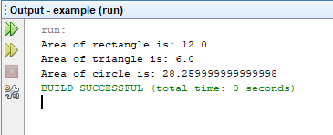

RESULT:

Thus the program for abstract class has been written and executed successfully.

EXPT: 7 DATE:

USER DEFINED EXCEPTION HANDLING

AIM:
To write a Java program to implement user defined exception handling.

ALGORITHM:

Step 1: Start the netbeansIDE8.2
Step 2: Goto FILE->new project->java->java application->click next
Step 3: Give the name for the application->Click Finish.
Step 4: Create a user defined exception called MyException which extends class Exception.
Step 5: Create try-catch block to handle the exception.
Step 6: Throw an exception of user defined type as an argument in main()
Step 7: Exception is handled using try, catch block
Step 8: Display the user defined exception.

PROGRAM:

import java.util.*;
class MyException extends Exception
{
String msg;
MyException()
{
msg = "UserDefined Exception: VoteNotEligibleException";
}

public String toString()
{
//System.out.println("Caught " + msg);
return msg;
}
}

class Excep
{
public static void main(String args[])
{ int age;
Scanner s=new Scanner(System.in);
System.out.println("Enter the age");
age=s.nextInt();
try
{
if(age < 18)
throw new MyException();
else
System.out.println("Person is eligible to vote");
System.out.println("Normal exit");
}
catch (MyException e)
{
System.out.println("Caught " + e);
}
}
}

OUTPUT:

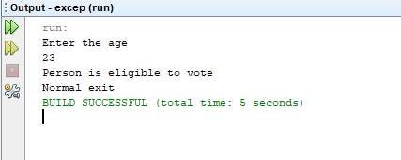

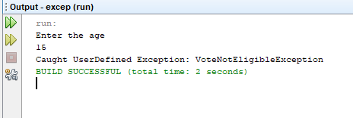

RESULT:

Thus the program user defined exception handling has been written and executed successfully.

EXPT:8aDATE:

FILE HANDLING - FILE OPERATION

AIM:
To write a Java program to implement the concepts of file.

ALGORITHM:

Step 1: Start the program
Step 2: Open the notepad and type the program and save the program as Filedemo.java
Step 3: Click on the Cmd Prompt , type cd C:\Java\jdk1.8\bin
Step 4: Now compile the Filedemo.java using javac Filedemo.java
Step 5: Before executing the Filedemo.java create another java file using notepad called Fib.java
Step 6: Execute the program using java Filedemo.java and give the input file name Fib.java
Step 7: Stop the program.

PROGRAM:
import java.util.Scanner; import java.io.File;
public class Filedemo
{
public static void main(String[] args)
{
Scanner input=new Scanner(System.in); String s=input.nextLine();
File f1=new File(s);
System.out.println("File Name:"+f1.getName()); System.out.println("Path:"+f1.getPath()); System.out.println("Abs Path:"+f1.getAbsolutePath()); System.out.println("Parent:"+f1.getParent());
System.out.println("This file is:"+(f1.exists()?"Exists":"Does not exists”));
System.out.println("Is file:"+f1.isFile()); System.out.println("Is Directory:"+f1.isDirectory()); System.out.println("Is Readable:"+f1.canRead()); System.out.println("IS Writable:"+f1.canWrite()); System.out.println("Is Absolute:"+f1.isAbsolute()); System.out.println("File Last Modified:"+f1.lastModified()); System.out.println("File Size:"+f1.length()+"bytes"); System.out.println("Is Hidden:"+f1.isHidden());

}
}

Input file:
Fib.java
public class Fib {
public static void main(String[] args) { int n1=0,n2=1,n3,i,count=10;
System.out.print(n1+" "+n2);
for(i=2;i<count;++i)
{
n3=n1+n2; System.out.print(" "+n3); n1=n2;
n2=n3;
}
}
}

OUTPUT:

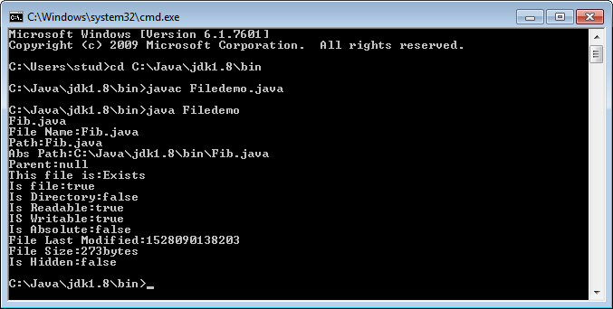

RESULT:

Thus the program for implementing the file concept has been written and executed successfully.

EXPT:8bDATE:

FILE HANDLING - FILE COPYING

AIM:
To write a Java program to implement the concepts of file copying.

ALGORITHM:
Step 1: Start the program
Step 2: Open the notepad and type the program and save the program as Filedemo.java
Step 3: Click on the Cmd Prompt -> cd C:\Java\jdk1.8\bin
Step 4: Now compile the Filedemo.java using javac Filedemo.java
Step 5: Before executing the Filedemo.java create another text file using notepad called file1.txt
Step 6: Execute the program using java Filedemo.java and give the input file name file1.txt. The file1 content is read and displayed.
Step 7: Stop the program.

PROGRAM 2:
import java.io.*;
class Filedemo
{
public static void main(String args[])
{
try
{
FileInputStream fin = new FileInputStream("file1.txt");
int c;

System.out.println(“The file content is:”);
while(( c = fin.read() ) != -1)
{
System.out.print((char)c);
}
fin.close();
}
catch(IOException e)
{
System.out.println("File not found " + e);
}
}
}
Input File : file1.txt
Chennai
Delhi
Mumbai
Kolkata

OUTPUT:

D:\>javac Filedemo.java

D:\>java Filedemo

The file content is:

Chennai

Delhi

Mumbai

Kolkata

RESULT:
Thus the program for implementing the file concept has been written and executed successfully.

EXPT:9aDATE:

PROGRAM USING MULTI-THREADING

AIM:
To write a Java program to implement the concepts of multithreading.

ALGORITHM:

Step 1: Start the netbeansIDE8.2
Step 2: Goto FILE-> new project->java->java application->click next
Step 3: Give the name for the application->Click Finish.
Step 4: Create a thread named MyThread. Override run() method.
Step 5: create 3 objects for Mythread class.call start() method by using 3 objects.
Step6:Randomly thread wil be executed.

PROGRAM:
import java.lang.*;
class MyThread extends Thread
{
public void run()
{
for (int x = 1; x < 5; x++)
{
System.out.println("Run by "+ Thread.currentThread().getName());
try
{
Thread.sleep(1000);
}
catch (InterruptedException ex)
{
System.out.println("Exception Caught" + ex);
}
}
}
}
class th
{
public static void main (String [] args)
{
// Creating Thread objects

MyThread t1= new MyThread();
MyThread t2 = new MyThread();
MyThread t3 = new MyThread();
t1.start();
t2.start();
t3.start();
}
}

OUTPUT:

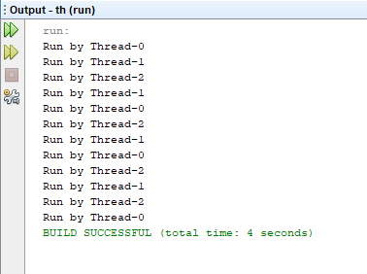

RESULT:

Thus the program for implementing the concept of multithreading has been written and executed successfully.

EXPT:9bDATE:

MULTI-THREADING TO GENERATE RANDOM NUMBER AND COMPUTE SQUARE AND CUBE

AIM:
To write a Java program to implement the concepts of multithreading to generate random number and to compute square if its even and compute cube if the number generated is od by implementing Runnable interface and extending Thread.

ALGORITHM:

Step 1: Start the netbeansIDE8.2
Step 2: Goto FILE-> new project->java->java application->click next
Step 3: Give the name for the application->Click Finish.
Step 4: Create three threads A, odd, even
Step 5: Thread A generates the random number
Step 6: If random number is even ,Thread even will display the square of the random number
Step 7: If random number is odd ,Thread odd will display the cube of the random number

PROGRAM:
import java.util.*;
class even implements Runnable
{
public int x;
public even(int a)
{
x=a;
}
public void run()
{
System.out.println("Thread Name:Even Thread and square is: " + x * x);
}
}
class odd implements Runnable
{
public int x;
public odd(int b)
{
x=b;
}
public void run()
{
System.out.println("Thread Name:Odd Thread and cube is :"+ x * x * x);
}
}
class A extends Thread
{
public String tname;
public Random r;
public Thread t1,t2;
public A(String s)
{
tname=s;
}
public void run()
{
int num=0;
r=new Random();
try
{
for(int i=0;i<20;i++)
{
num=r.nextInt(50);
System.out.println("main thread and generated number is"+num);
if(num%2==0)
{
t1=new Thread(new even(num));
t1.start();
}else{
t2=new Thread(new odd(num));
t2.start();
}
Thread.sleep(1000);
System.out.println(" ");
}
}
catch(InterruptedException ex)
{
System.out.println(ex.getMessage());
}
}
}
public class threadeg
{
public static void main(String[] args)
{
A a=new A("one");
a.start();
}
}

OUTPUT:

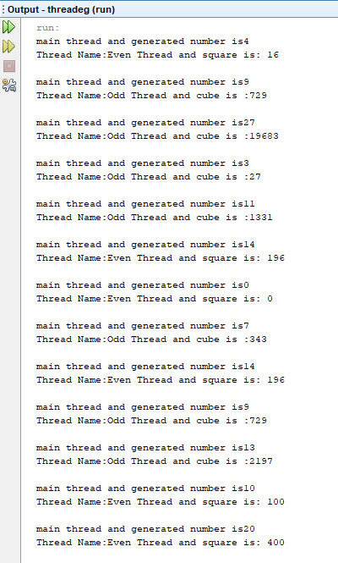

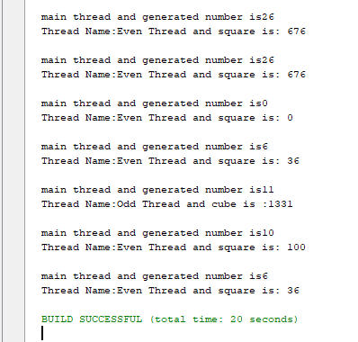

RESULT:

Thus the program for implementing the concept of multithreading has been written and executed successfully.

EXPT:10 DATE:

PROGRAM USING CREATE GENERIC FUNCTION

AIM:
To write a Java program to find the maximum value in a given generic function.

ALGORITHM:

Step 1: Start the netbeansIDE8.2
Step 2: Goto FILE-> new project->java->java application-.click next
Step 3: Give the name for the application-.Click Finish.
Step 4: Create generic method class called T extends with three objects x,y,z.
Step 5: Initially assume x as max and compare it with y and z.
Step 6: Find the maximum and return it to the main function

PROGRAM:
import java.lang.*;
import java.util.*;
public class Comp
{
public static <T extends Comparable<T>> T maximum(T x, T y, T z)
{
T max = x;
if(y.compareTo(max) > 0) {
max = y;
}
if(z.compareTo(max)>0)
{
max = z; // z is the largest now
}
return max; // returns the largest object
}
public static void main(String args[])
{System.out.println("Max of 3, 4, 5 is: "+maximum( 3, 4, 5 ));
System.out.printf("Max of 6.6, 8.8, 7.7 is: "+maximum( 6.6, 8.8, 7.7 ));
}
}

OUTPUT:
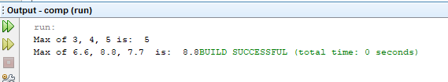

RESULT:
Thus the program for finding the maximum value using generic function has been written and executed successfully.

EXPT: 11 DATE:

CALCULATOR USING EVENT-DRIVEN PROGRAMMING

AIM:
To write a Java program to implement the calculator using event driven programming.

ALGORITHM:
Step 1: Start the program
Step 2: Open the notepad and type the program and save the program as Calculator.java
Step 3:Create the class Calculator. Define and declare its variables.
Step 4: Using Calculator constructor create buttons. Create an object of the JFrame class and set some of its properties like its title, visibility, background color, layout property etc. using the method of the JFrame class.
Step 5: Using actionPerformed() method define the function that has to be done when the corresponding button is pressed.
Step 6: Click on the Cmd Prompt -> cd C:\Java\jdk1.8\bin
Step 7: Now compile the Filedemo.java using javac Calculator.java
Step 8: Execute the program using command java Calculator

PROGRAM:
import javax.swing.*;
import java.awt.event.*;
class Calc implements ActionListener
{
JFrame f;
JTextField t;
JButton b1,b2,b3,b4,b5,b6,b7,b8,b9,b0,bdiv,bmul,bsub,badd,bdec,beq,bdel,bclr;
static double a=0,b=0,result=0;
static int operator=0;
Calc()
{
f=new JFrame("Calculator");
t=new JTextField();
b1=new JButton("1");
b2=new JButton("2");
b3=new JButton("3");
b4=new JButton("4");
b5=new JButton("5");
b6=new JButton("6");
b7=new JButton("7");
b8=new JButton("8");
b9=new JButton("9");
b0=new JButton("0");
bdiv=new JButton("/");
bmul=new JButton("*");
bsub=new JButton("-");
badd=new JButton("+");
bdec=new JButton(".");
beq=new JButton("=");
bdel=new JButton("Delete");
bclr=new JButton("Clear");
t.setBounds(30,40,280,30);
b7.setBounds(40,100,50,40);
b8.setBounds(110,100,50,40);
b9.setBounds(180,100,50,40);
bdiv.setBounds(250,100,50,40);
b4.setBounds(40,170,50,40);
b5.setBounds(110,170,50,40);
b6.setBounds(180,170,50,40);
bmul.setBounds(250,170,50,40);
b1.setBounds(40,240,50,40);
b2.setBounds(110,240,50,40);
b3.setBounds(180,240,50,40);
bsub.setBounds(250,240,50,40);
bdec.setBounds(40,310,50,40);
b0.setBounds(110,310,50,40);
beq.setBounds(180,310,50,40);
badd.setBounds(250,310,50,40);
bdel.setBounds(60,380,100,40);
bclr.setBounds(180,380,100,40);
f.add(t);
f.add(b7);
f.add(b8);
f.add(b9);
f.add(bdiv);
f.add(b4);
f.add(b5);
f.add(b6);
f.add(bmul);
f.add(b1);
f.add(b2);
f.add(b3);
f.add(bsub);
f.add(bdec);
f.add(b0);
f.add(beq);
f.add(badd);
f.add(bdel);
f.add(bclr);
f.setLayout(null);
f.setVisible(true);
f.setSize(350,500);
f.setDefaultCloseOperation(JFrame.EXIT_ON_CLOSE);
f.setResizable(false);
b1.addActionListener(this);
b2.addActionListener(this);
b3.addActionListener(this);
b4.addActionListener(this);
b5.addActionListener(this);
b6.addActionListener(this);
b7.addActionListener(this);
b8.addActionListener(this);
b9.addActionListener(this);
b0.addActionListener(this);
badd.addActionListener(this);
bdiv.addActionListener(this);
bmul.addActionListener(this);
bsub.addActionListener(this);
bdec.addActionListener(this);
beq.addActionListener(this);
bdel.addActionListener(this);
bclr.addActionListener(this);
}
public void actionPerformed(ActionEvent e)
{
if(e.getSource()==b1)
t.setText(t.getText().concat("1"));
if(e.getSource()==b2)
t.setText(t.getText().concat("2"));
if(e.getSource()==b3)
t.setText(t.getText().concat("3"));
if(e.getSource()==b4)
t.setText(t.getText().concat("4"));
if(e.getSource()==b5)
t.setText(t.getText().concat("5"));
if(e.getSource()==b6)
t.setText(t.getText().concat("6"));
if(e.getSource()==b7)
t.setText(t.getText().concat("7"));
if(e.getSource()==b8)
t.setText(t.getText().concat("8"));
if(e.getSource()==b9)
t.setText(t.getText().concat("9"));
if(e.getSource()==b0)
t.setText(t.getText().concat("0"));
if(e.getSource()==bdec)
t.setText(t.getText().concat("."));
if(e.getSource()==badd)
{
a=Double.parseDouble(t.getText());
operator=1;
t.setText("");
}
if(e.getSource()==bsub)
{
a=Double.parseDouble(t.getText());
operator=2;
t.setText("");
}
if(e.getSource()==bmul)
{
a=Double.parseDouble(t.getText());
operator=3;
t.setText("");
}
if(e.getSource()==bdiv)
{
a=Double.parseDouble(t.getText());
operator=4;
t.setText("");
}
if(e.getSource()==beq)
{
b=Double.parseDouble(t.getText());
switch(operator)
{
case 1: result=a+b;
break;
case 2: result=a-b;
break;
case 3: result=a*b;
break;
case 4: result=a/b;
break;
default: result=0;
}
t.setText(""+result);
}
if(e.getSource()==bclr)
t.setText("");
if(e.getSource()==bdel)
{
String s=t.getText();
t.setText("");
for(int i=0;i<s.length()-1;i++)
t.setText(t.getText()+s.charAt(i));
}
}
public static void main(String[] args)
{
new Calc();
}
}

OUTPUT:
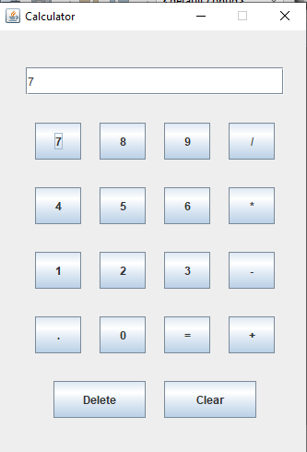
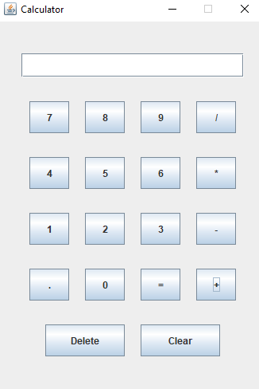
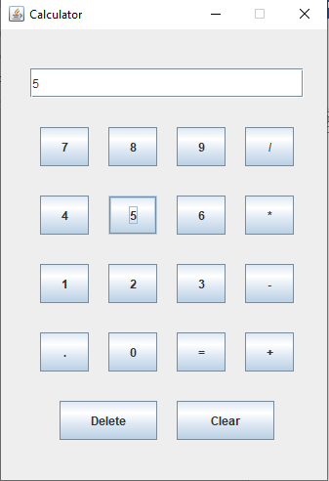
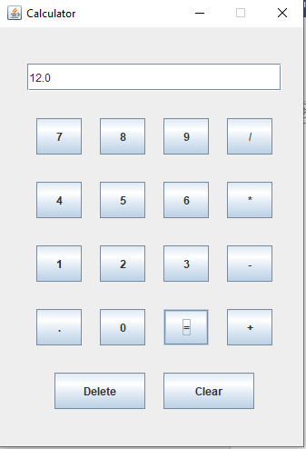

RESULT:
Thus the program is implemented and executed successfully.

EXPT: 12 DATE:
STUDENT DATABASE MANAGEMENT SYSTEM USING EVENT-DRIVEN AND JDBC.

AIM:
To write a Java program to implement Student database management system using MySql database.

Database:
A database is an application that stores the organized collection of records. It can be accessed and manage by the user very easily. It allows us to organize data into tables, rows, columns, and indexes to find the relevant information very quickly.

MySQL:
MySQL is a relational database management system based on the Structured Query Language.
- It allows us to implement database operations on tables, rows, columns,
- and indexes.
- It defines the database relationship in the form of tables (collection of rows and columns), also known as relations.
- It provides the Referential Integrity between rows or columns of various tables.
- It allows us to updates the table indexes automatically.
- It uses many SQL queries and combines useful information from multiple tables for the end-users.
Database creation:
The CREATE DATABASE statement is used to create a new SQL database.
Syntax:
CREATE DATABASE databasename;
Eg: CREATE DATABASE studentname;

Table creation:
The CREATE TABLE statement is used to create a new table in a database.
Syntax:
CREATE TABLE table_name (
column1 datatype,
column2 datatype,
column3 datatype, ....);
Eg:
CREATE TABLE student (id int,name varchar(255),address varchar(255));

Showing table:
MySQL SHOW command is a special query in MySQL to view the information schema of any records stored on the database.
Syntax:
SHOW TABLES

MySQL SELECT statement:
Syntax:
SELECT column1, column2, ...
FROM table_name;

Eg:
SELECT * FROM student;
MySQL INSERT statement:
MySQL INSERT statement is used to store or add data in MySQL table within the database. We can perform insertion of records in two ways using a single query in MySQL:
- Insert record in a single row
- Insert record in multiple rows
Insert record in a single row:

Syntax:
INSERT INTO table_name ( field1, field2,...fieldN )
VALUES
( value1, value2,...valueN );
Eg:
INSERT INTO student (id, name, address)VALUES (101, 'Peter', 'chennai');
INSERT INTO student (id, name, address)VALUES (102, 'Preethi', 'coimbatore');
Insert record in multiple rows:
Syntax:
INSERT INTO table_name VALUES
( value1, value2,...valueN )
( value1, value2,...valueN )
...........
( value1, value2,...valueN );

Eg:
- INSERT INTO People VALUES
- (102, 'Joseph', 'Developer', 30),
- (103, 'Mike', 'Leader', 28),
- (104, 'Stephen', 'Scientist', 45);

MySQL UPDATE:
MySQL UPDATE query is a DML statement used to modify the data of the MySQL table within the database.
Syntax:
UPDATE table_name
SET column_name1 = new-value1,
column_name2=new-value2, ...
[WHERE Clause]
Eg:
UPDATE [LOW_PRIORITY] [IGNORE] table_name
SET column_assignment_list
[WHERE condition]

MySQL DELETE
MySQL DELETE statement is used to remove records from the MySQL table that is no longer required in the database. This query in MySQL deletes a full row from the table and produces the count of deleted rows. It also allows us to delete more than one record from the table within a single query.

Syntax:
DELETE FROM table_name WHERE condition;
Eg:
DELETE FROM Employees WHERE emp_id=107;

QUERY:
CREATE TABLE student (id int,name varchar(255),address varchar(255));
INSERT INTO student (id, name, address)VALUES (101, 'Peter', 'chennai');
INSERT INTO student (id, name, address)VALUES (102, 'Preethi', 'coimbatore');
SELECT * FROM student;

OUTPUT:
Table is created.
Rows are inserted
id name address
101 Peter chennai
102 Preethi coimbatore

PROGRAM:
import java.sql.*;
class MysqlCon
{
public static void main(String args[])
{
try
{
Class.forName("com.mysql.jdbc.Driver");
Connection con=DriverManager.getConnection( "jdbc:mysql://localhost:3306/ece","redhat0","redhat");
Statement stm=con.createStatement();
ResultSet rs=stm.executeQuery("select * from student");
System.out.println(“Before inserting the table content are:”);
System.out.println(“ID Name Address”);
while(rs.next())
System.out.println(rs.getInt(1)+" "+rs.getString(2)+" "+rs.getString(3));

PreparedStatement stmt=con.prepareStatement("insert into student values(?,?)");

stmt.setInt(1,103)

stmt.setString(2,"Ram");

tmt.setString(3,"Kanchipuram");

int i=stmt.executeUpdate();
System.out.println(i+" records inserted");
System.out.println(“After inserting the table content are:”);
while(rs.next())
System.out.println(rs.getInt(1)+" "+rs.getString(2)+" "+rs.getString(3));
con.close();
}
catch(Exception e)
{
System.out.println(e);}
}
}

OUTPUT:

Before inserting the table content are:

id name address
101 Peter chennai
102 Preethi coimbatore

1 record inserted

After inserting the table content are:
id name address

101 Peter chennai
102 Preethi coimbatore

103 Ram Kanchipuram

RESULT:
Thus the student database is created and implemented and executed successfully.

EXPT: 13 DATE:
CONTENT BEYOND THE SYLLABUS
2-D SHAPES

AIM:

To write a Java program to implement 2-D shapes .

ALGORITHM:

Step 1: Start the program
Step 2: Open the notepad and type the program and save the program as Draw2DObjects.java
Step 3: Import graphics and geometric packages.
Step 4: Create the class Draw2DObjects. Define and declare its variables. Step 5: Click on the Cmd Prompt → cd C:\Java\jdk1.8\bin
Step 6: Now compile the Filedemo.java using javac Draw2DObjects.java
Step 7: Execute the program using java Draw2DObjects

PROGRAM:

import java.awt.Canvas; import java.awt.Graphics; import java.awt.Graphics2D; import java.awt.Shape;
import java.awt.geom.Ellipse2D; import java.awt.geom.GeneralPath; import java.awt.geom.Line2D; import java.awt.geom.Rectangle2D;
import java.awt.geom.RoundRectangle2D; import javax.swing.JFrame;
public class Draw2DObjects extends JFrame
{
Shape shapes[] = new Shape[5]; public static void main(String args[]) {
Draw2DObjects app = new Draw2DObjects();
}

public Draw2DObjects() { add("Center", new MyCanvas());
shapes[0] = new Line2D.Double(0.0, 0.0, 100.0, 100.0);
shapes[1] = new Rectangle2D.Double(10.0, 100.0, 200.0, 200.0);
shapes[2] = new Ellipse2D.Double(20.0, 200.0, 100.0, 100.0);
GeneralPath path = new GeneralPath(new Line2D.Double(300.0, 100.0, 400.0,

150.0));

25.0);

}

path.append(new Line2D.Double(25.0, 175.0, 300.0, 100.0), true); shapes[3] = path;
shapes[4] = new RoundRectangle2D.Double(350.0, 250, 200.0, 100.0, 50.0,

setSize(400, 400); setDefaultCloseOperation(JFrame.EXIT_ON_CLOSE); setVisible(true);

class MyCanvas extends Canvas
{ public void paint(Graphics graphics) {
Graphics2D g = (Graphics2D) graphics; for (int i = 0; i < shapes.length; ++i) {
if (shapes[i] != null) g.draw(shapes[i]);
}
}
}
}

OUTPUT:

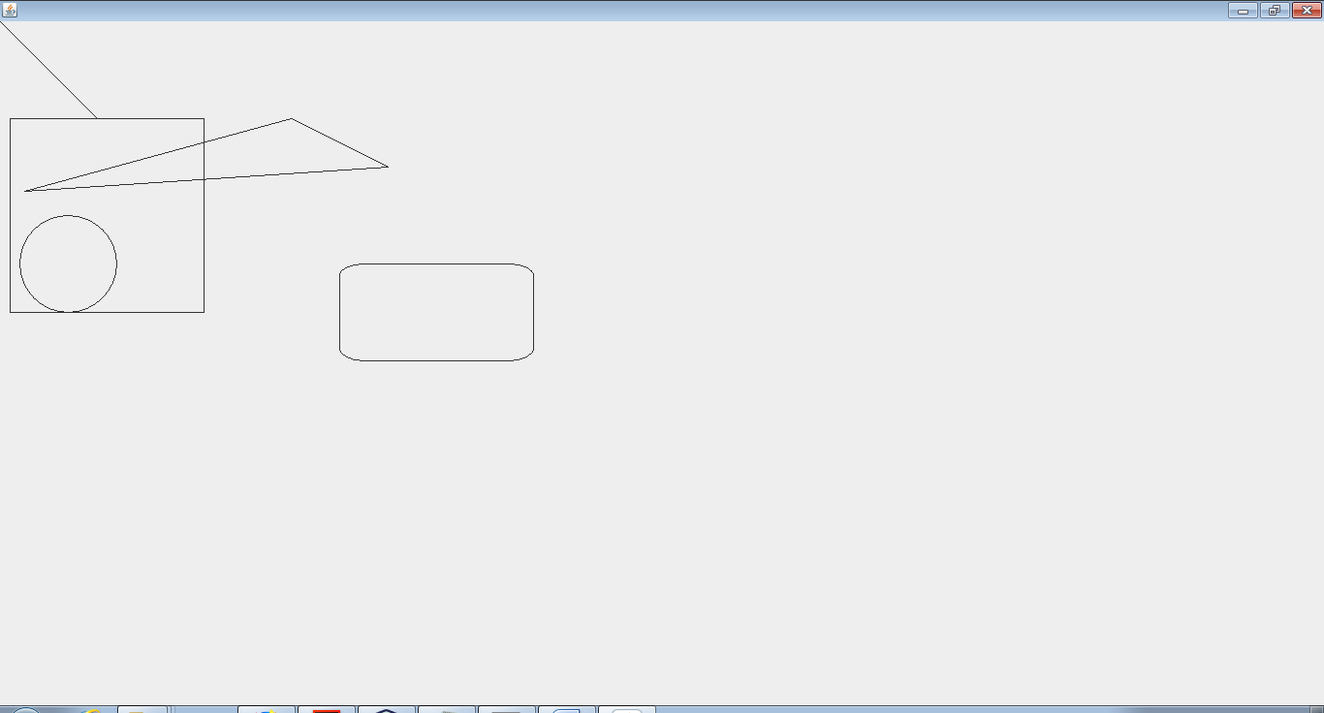

RESULT:

Thus the 2-D shapes program has been written and executed successfully.

SAMPLE JAVA PROGRAMS

PROGRAM 1:
// Program to maintain Student information
class Student
{
// Defining Fields
String name;
int rollno, m1,m2,m3,total;
float avg;

//Defining Constructor
Student()
{
name = "Nimal";
rollno = 105;
m1=81;
m2=85;
m3 = 90;
}

//Defining Methods
void findAverage()
{
total = total+m1+m2+m3;
avg = (float)total/3;
}

void display()
{
System.out.println(" NAME = " +name );
System.out.println(" ROLL NO = " +rollno);
System.out.println(" MARK1 = " +m1);
System.out.println(" MARK1 = " +m2);
System.out.println(" MARK1 = " +m3);
System.out.println(" TOTAL = " +total);
System.out.println(" AVERAGE = " +avg);
}

}
//Main Program
class TestStudent
{
public static void main(String arg[])
{
//Creatiing Objects
Student s1 = new Student();

//Calling Method
s1.findAverage();
s1.display();
}
}

INPUT AND OUTPUT 1:
Z:\java Lab>java TestStudent
NAME = Nimal
ROLL NO = 105
MARK1 = 81
MARK1 = 85
MARK1 = 90
TOTAL = 256
AVERAGE = 85.333336

PROGRAM 2:
// Program to maintain Employee information
import java.util.*;
class Employee
{
// Defining fields
String emp_name,mail_id,address;
long emp_id, mobile_no;
double basic, da, hra , pf, club_fund,net_pay,gross_pay;
Scanner in = new Scanner(System.in);

//Defining methods
void input()
{
System.out.println("Enter Employee Name");
emp_name = in.next();
System.out.println("Enter Employee Id");
emp_id = in.nextInt();
System.out.println("Enter Employee Adrees");
address = in.next();
System.out.println("Enter Employee Mail ID");
mail_id = in.next();
System.out.println("Enter Employee Mobile Number");
mobile_no = in.nextLong();
System.out.println("Enter Employee Basic Pay");
basic = in.nextDouble();
}

void computeSalary()
{
da = basic * 97.0/100;
hra = basic * 10.0/100;
pf = basic * 12.0/100;
club_fund= basic * 0.1/100;
net_pay = basic + da + hra;
gross_pay = basic + da + hra + pf + club_fund;
}

void display()
{
System.out.println(" " );
System.out.println(" **** EMPLOYEE SALARY DETAIL **** " );
System.out.println(" EMPLOYEE NAME = " +emp_name );
System.out.println(" EMPLOYEE ID = " + emp_id);
System.out.println(" ADDRESS = " + address);
System.out.println(" MAIL ID = " +mail_id);
System.out.println(" MOBILE NUMBER = " +mobile_no);
System.out.println(" BASIC = " + basic);
System.out.println(" DA = " + da);
System.out.println(" HRA = " + hra);
System.out.println(" PF = " + pf );
System.out.println(" STAFF CLUB FUND = " + club_fund);
System.out.println(" GROSS PAY = " + gross_pay);
System.out.println(" NETPAY = " + net_pay);
}
}

// Main Progarm
class TestEmployee
{
public static void main(String arg[])
{
//Creatiing Objects
Employee e1 = new Employee();

//Calling Method
e1.input();
e1.computeSalary();
e1.display();
}
}

INPUT AND OUTPUT 2:
z:\java Lab>java TestEmployee
Enter Employee Name
MANI
Enter Employee Id
1001
Enter Employee Adrees
Chennai
Enter Employee Mail ID
mani@saec.ac.in
Enter Employee Mobile Number
9884620510
Enter Employee Basic Pay
22000

**** EMPLOYEE SALARY DETAIL ****
EMPLOYEE NAME = MANI
EMPLOYEE ID = 1001
ADDRESS = Chennai
MAIL ID = mani@saec.ac.in
MOBILE NUMBER = 9884620510
BASIC = 22000.0
DA = 21340.0
HRA = 2200.0
PF = 2640.0
STAFF CLUB FUND = 22.0
GROSS PAY = 48202.0
NETPAY = 45540.0

PROGRAM 3:
// Program to maintain Bank Account information
import java.util.*;
class Account
{
String customer_name;
int balance, amount;
long mobile_no, acc_no;
Scanner in = new Scanner(System.in);

// Defining Constructor
Account()
{
balance = 1000;
}

//Defining methods
void getData()
{
System.out.println("Enter Customer Name");
customer_name = in.next();
System.out.println("Enter Account Number ");
acc_no = in.nextInt();
System.out.println("Enter Customer Mobile Number");
mobile_no = in.nextLong();
}

void deposit()
{
System.out.println("Enter the amount to deposit");
amount = in.nextInt();
balance = balance + amount;
System.out.println("Amount Deposited Sucessfully");
System.out.println("Balance = " + balance);
}

void withdraw()
{
System.out.println("Enter the amount to withdraw");
amount = in.nextInt();
if(balance < (1000+amount))
{
System.out.println("Not enough amount in Account " );
}
else
{
balance = balance - amount;
}
System.out.println("Balance = " + balance);
}

// toSring method
public String toString()
{
System.out.println("Customer Name = " + customer_name);
System.out.println("Account Number = " + acc_no);
System.out.println("Mobile Number = " + mobile_no);
System.out.println("Balance = " + balance);
return " ";
}
}

// Main program
class TestAccount
{
public static void main(String arg[])
{
Scanner in = new Scanner(System.in);
int choice , amount;
Account acc = new Account();
acc.getData();
System.out.println(acc); // invoke toString()
for(; ; )
{

System.out.println("Enter your choice \n 1.Deposit\n 2.Withdrawn
\n 3.Exit");
choice = in.nextInt();
switch(choice)
{
case 1:
acc.deposit();
break;
case 2:

acc.withdraw();
break;
case 3:
System.exit(1);
default :
System.out.println(" Invalid Choice");
break;
}
}

}
}

INPUT AND OUTPUT 3:
Z:\java Lab>java TestAccount
Enter Customer Name
Partheeban
Enter Account Number
500615
Enter Customer Mobile Number
9884620510
Customer Name = Partheeban
Account Number = 500615
Mobile Number = 9884620510
Balance = 1000

Enter your choice
1.Deposit
2.Withdrawn
3.Exit
1
Enter the amount to deposit
500
Amount Deposited Sucessfully
Balance = 1500
Enter your choice
1.Deposit
2.Withdrawn
3.Exit
2
Enter the amount to withdraw
2000
Not enough amount in Account
Balance = 1500
Enter your choice
1.Deposit
2.Withdrawn
3.Exit
2
Enter the amount to withdraw
200
Balance = 1300
Enter your choice
1.Deposit
2.Withdrawn
3.Exit
3
Program 4:

// Synchronization program:
class SyncDemo implements Runnable
{
public void run()
{
display();

}
synchronized void display() // synchronized method can aceesed by only one thread at a time
{
for (int x = 1; x < 10; x++)
{
System.out.println("Run by "+ Thread.currentThread().getName());
try
{
Thread.sleep(1000);
}
catch (InterruptedException ex)
{
System.out.println("Exception Caught" + ex);
}
}
}
public static void main (String [] args)
{
// Make one Runnable
SyncDemo nr = new SyncDemo();
Thread one = new Thread(nr,"Thread-A");
Thread two = new Thread(nr,"Thread-B");
Thread three = new Thread(nr,"Thread-C");
//Start the thread
one.start();
two.start();
three.start();
}
}

Output :
Run by Thread-A
Run by Thread-A
Run by Thread-A
Run by Thread-A
Run by Thread-A
Run by Thread-A
Run by Thread-A
Run by Thread-A
Run by Thread-A
Run by Thread-C
Run by Thread-C
Run by Thread-C
Run by Thread-C
Run by Thread-C
Run by Thread-C
Run by Thread-C
Run by Thread-C
Run by Thread-C
Run by Thread-B
Run by Thread-B
Run by Thread-B
Run by Thread-B
Run by Thread-B
Run by Thread-B
Run by Thread-B
Run by Thread-B
Run by Thread-B

Note : Notice the output , As Synchronized method allow only one thread to be executed at a time , all the three threads are executed serially, that is one after another , not concurrently.

